Parabolic Open Curves
# Source: AI Source: Provided by: [Data Path: Persons Table -> ID Column: 1, Name_En Column: Motasem Essam] -> From: [ChatGPT] on [7/25/2026]
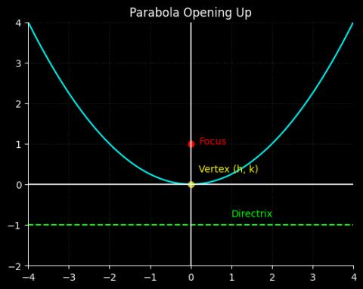
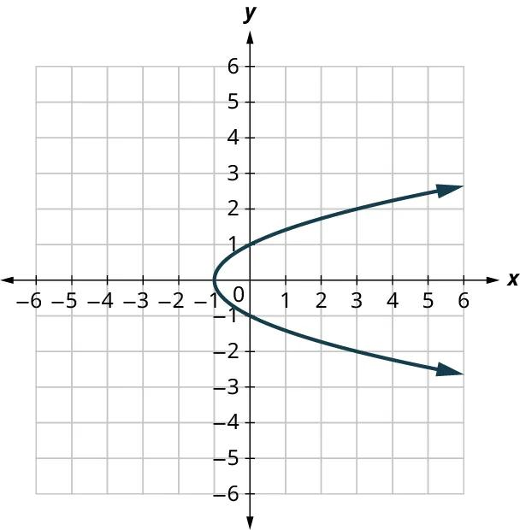
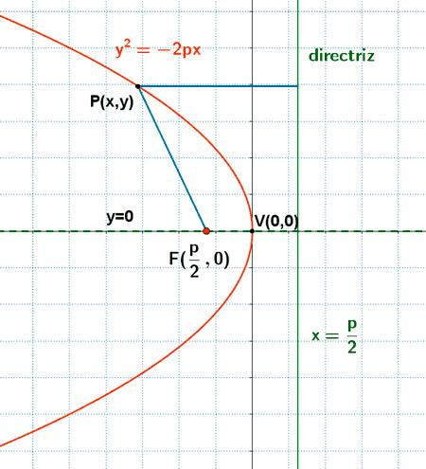
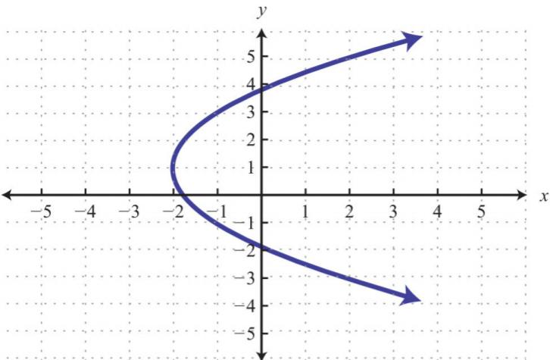
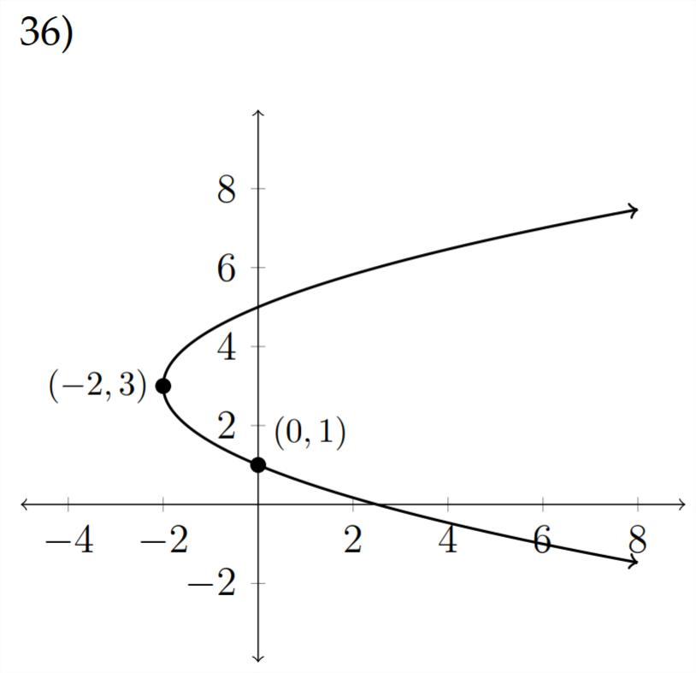
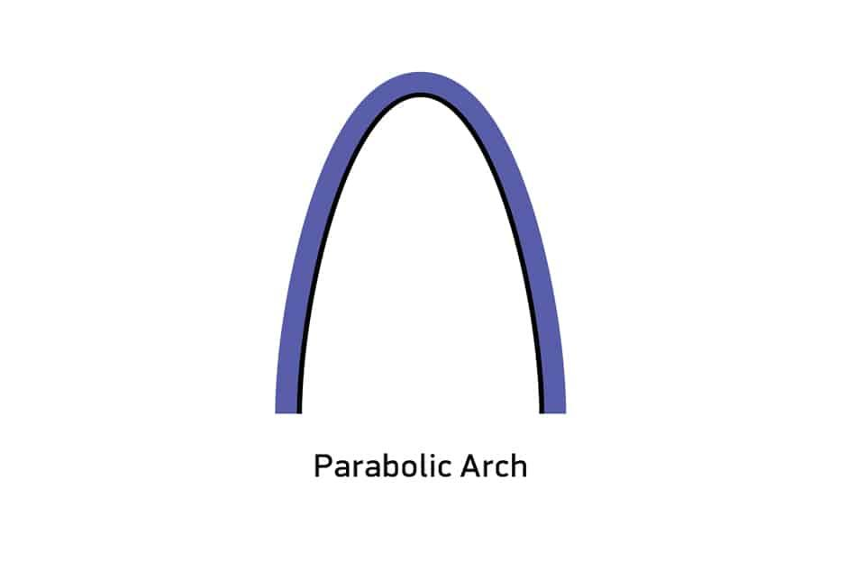

Definition
# Source: AI Source: Provided by: [Data Path: Persons Table -> ID Column: 1, Name_En Column: Motasem Essam] -> From: [ChatGPT] on [7/25/2026]
A Parabolic Open Curve is an open curved shape that follows part or all of a parabola, with two endpoints or extending indefinitely in one or both directions.
A parabola is a conic section defined by the set of points that are equally distant from a fixed point (the focus) and a fixed line (the directrix).
$$\boxed{\text{Parabolic Open Curve}=\text{Parabolic Form}+\text{Continuous Curvature}+\text{Open Boundary}}$$
Unlike a circle or ellipse, a complete parabola does not close on itself.

Characteristics
# Source: AI Source: Provided by: [Data Path: Persons Table -> ID Column: 1, Name_En Column: Motasem Essam] -> From: [ChatGPT] on [7/25/2026]
A Parabolic Open Curve:
- Is open.
- Has continuous curvature.
- Does not form a closed boundary.
- Has a characteristic vertex.
- Has an axis of symmetry.
- Can open upward, downward, left, or right.
- Can be a finite portion of a parabola or an entire unbounded parabola.
- Does not enclose an area by itself.
- Can be symmetric or asymmetric depending on the selected portion.

Types of Parabolic Open Curves

1. Upward-Opening Parabolic Curve
# Source: AI Source: Provided by: [Data Path: Persons Table -> ID Column: 1, Name_En Column: Motasem Essam] -> From: [ChatGPT] on [7/25/2026]
The parabola opens upward.
$$\boxed{y=a{\left(x-h\right)}^{2}+k, a>0}$$
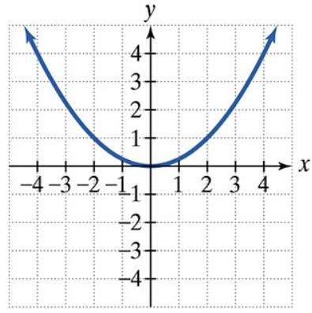
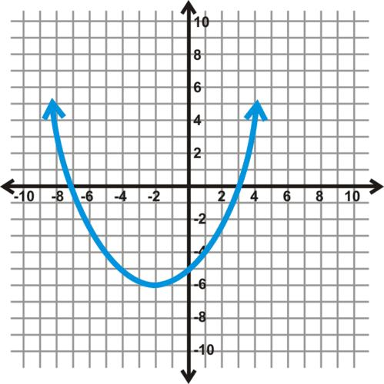
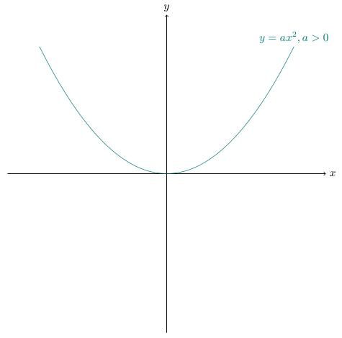
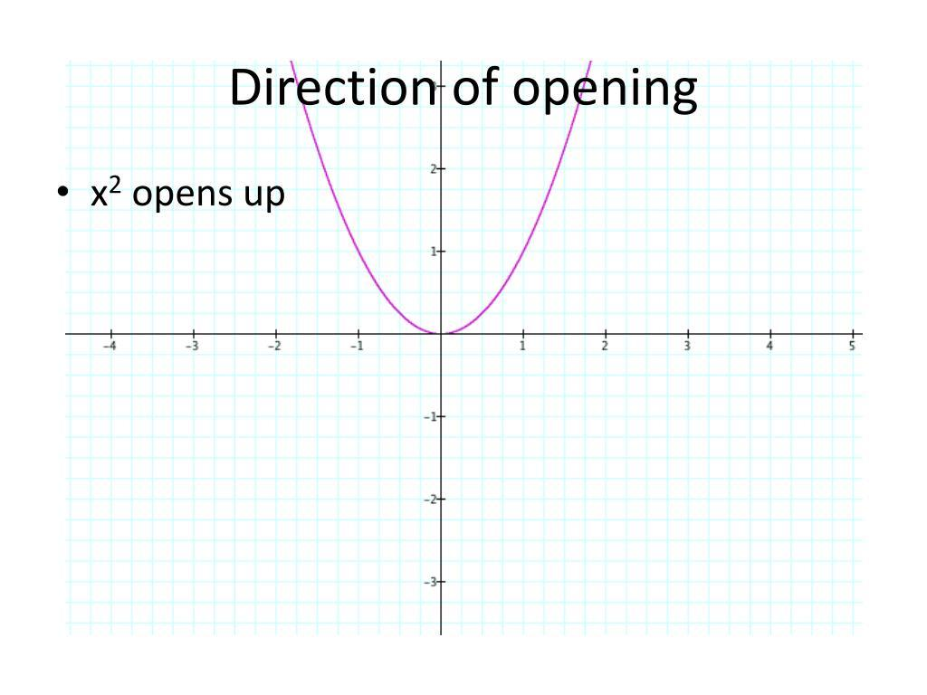
The vertex is the lowest point of the parabola.

2. Downward-Opening Parabolic Curve
# Source: AI Source: Provided by: [Data Path: Persons Table -> ID Column: 1, Name_En Column: Motasem Essam] -> From: [ChatGPT] on [7/25/2026]
The parabola opens downward.
$$\boxed{y=a{\left(x-h\right)}^{2}+k, a<0}$$
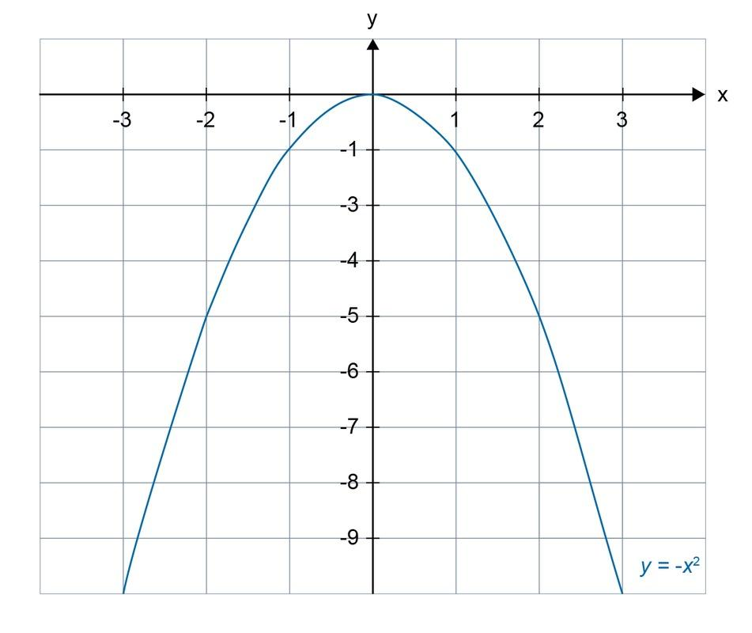
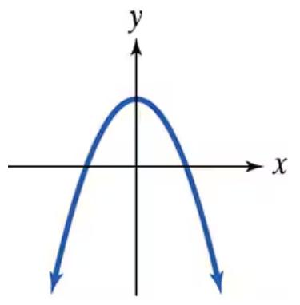
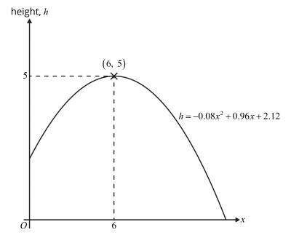
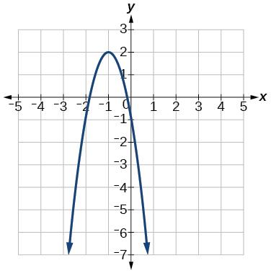
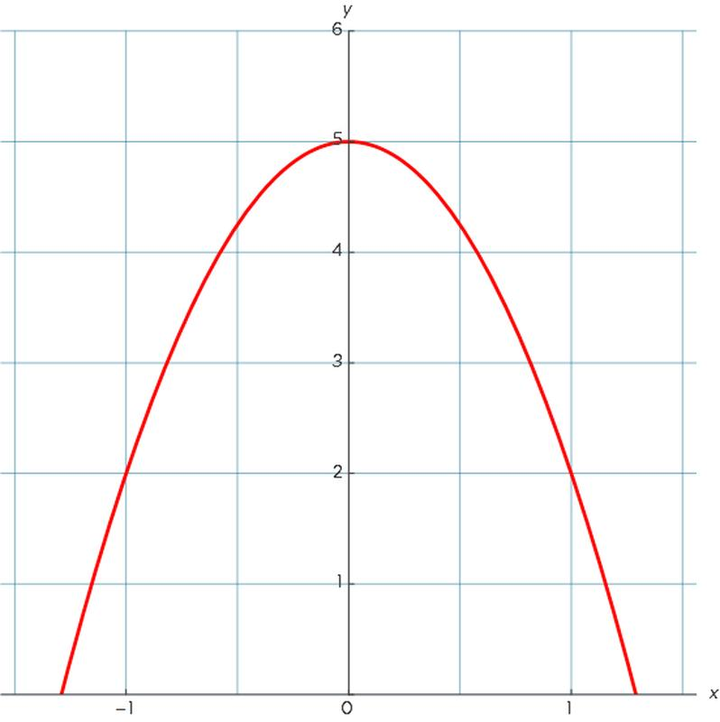
The vertex is the highest point.

3. Right-Opening Parabolic Curve
# Source: AI Source: Provided by: [Data Path: Persons Table -> ID Column: 1, Name_En Column: Motasem Essam] -> From: [ChatGPT] on [7/25/2026]
The parabola opens toward the right.
$$\boxed{x=a{\left(y-k\right)}^{2}+h}$$
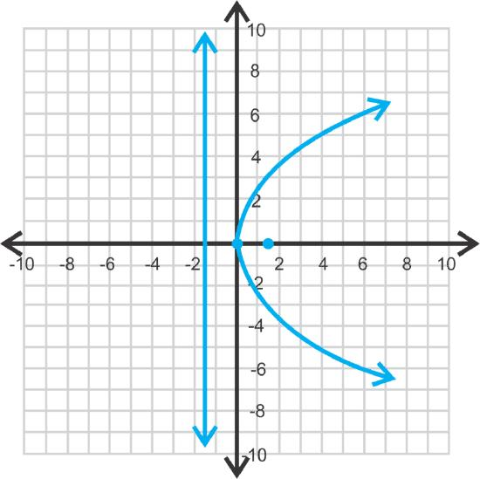
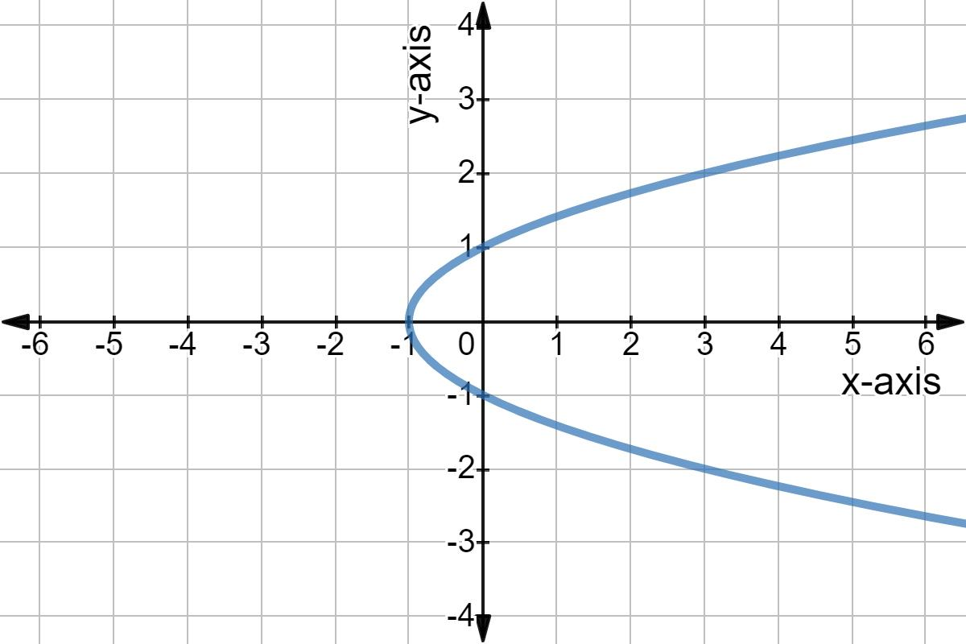
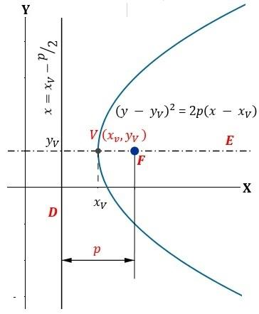
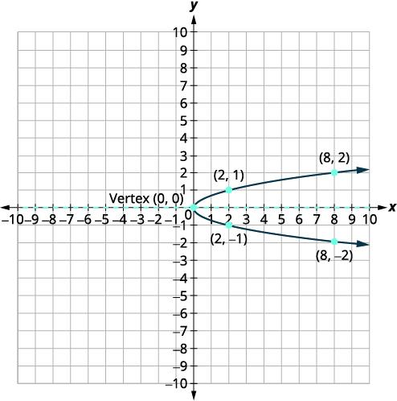

4. Left-Opening Parabolic Curve
# Source: AI Source: Provided by: [Data Path: Persons Table -> ID Column: 1, Name_En Column: Motasem Essam] -> From: [ChatGPT] on [7/25/2026]
The parabola opens toward the left.
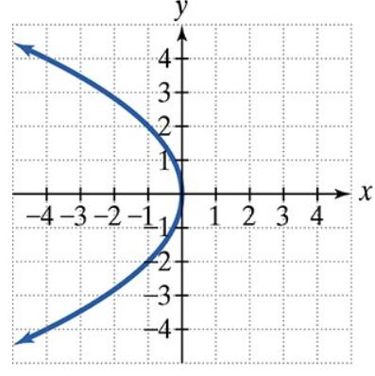
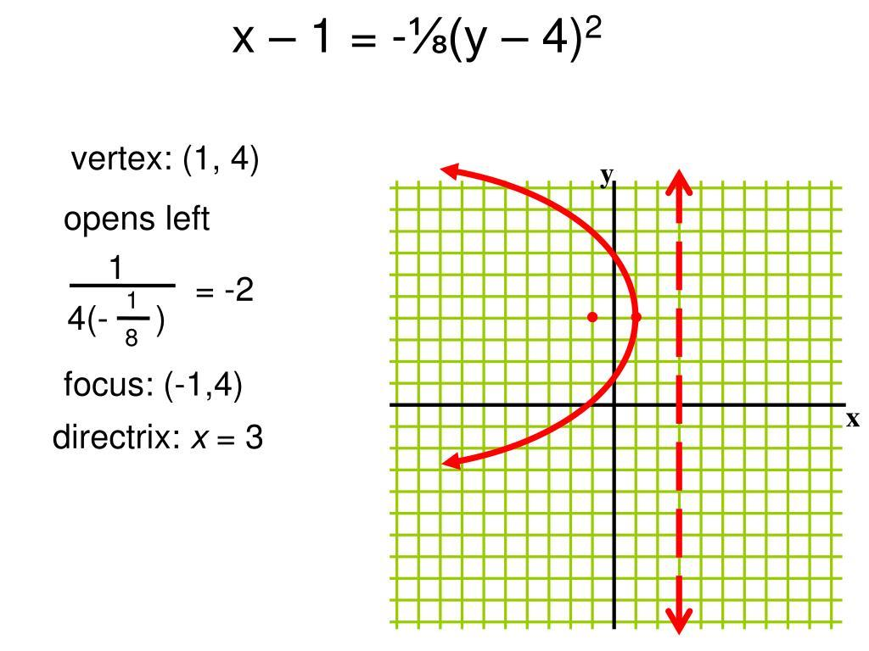
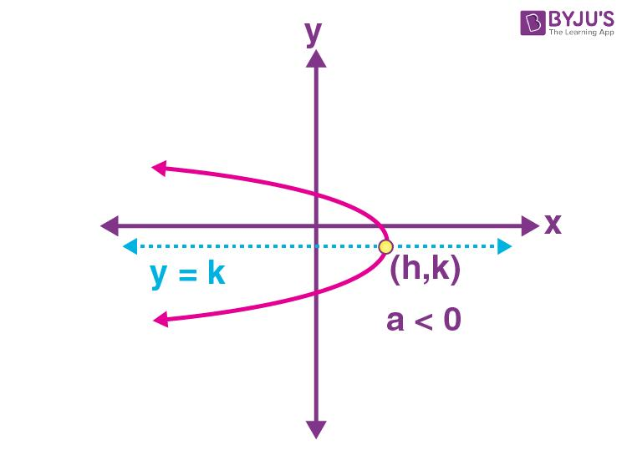
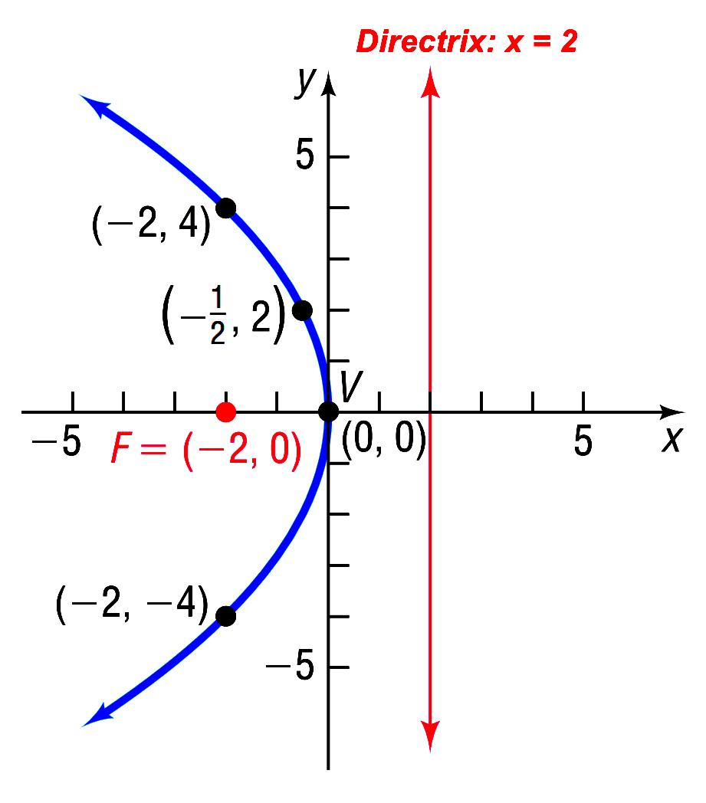
It is the horizontal counterpart of an upward- or downward-opening parabola.

5. Symmetric Parabolic Open Curve
# Source: AI Source: Provided by: [Data Path: Persons Table -> ID Column: 1, Name_En Column: Motasem Essam] -> From: [ChatGPT] on [7/25/2026]
A selected portion of a parabola is symmetric about its axis of symmetry.
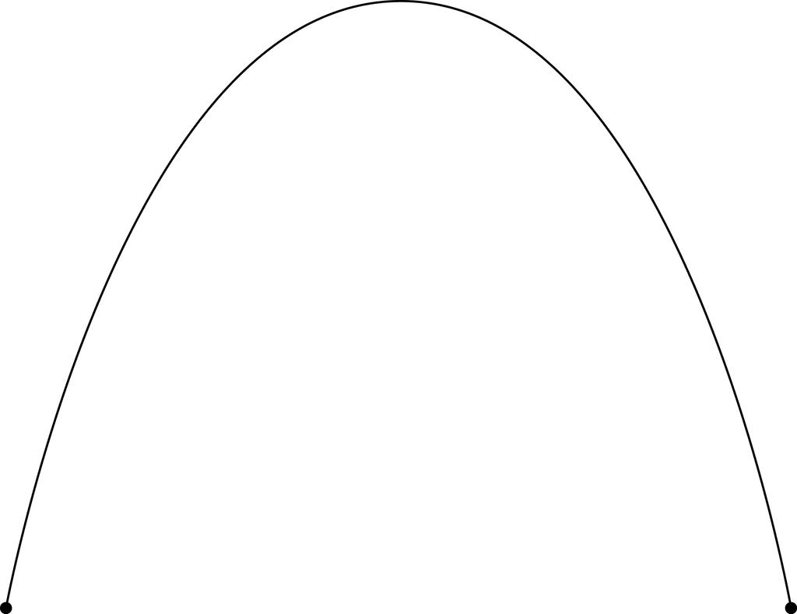
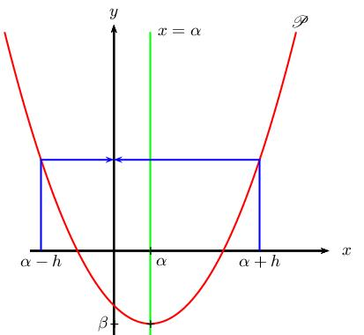
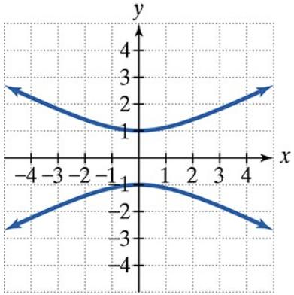
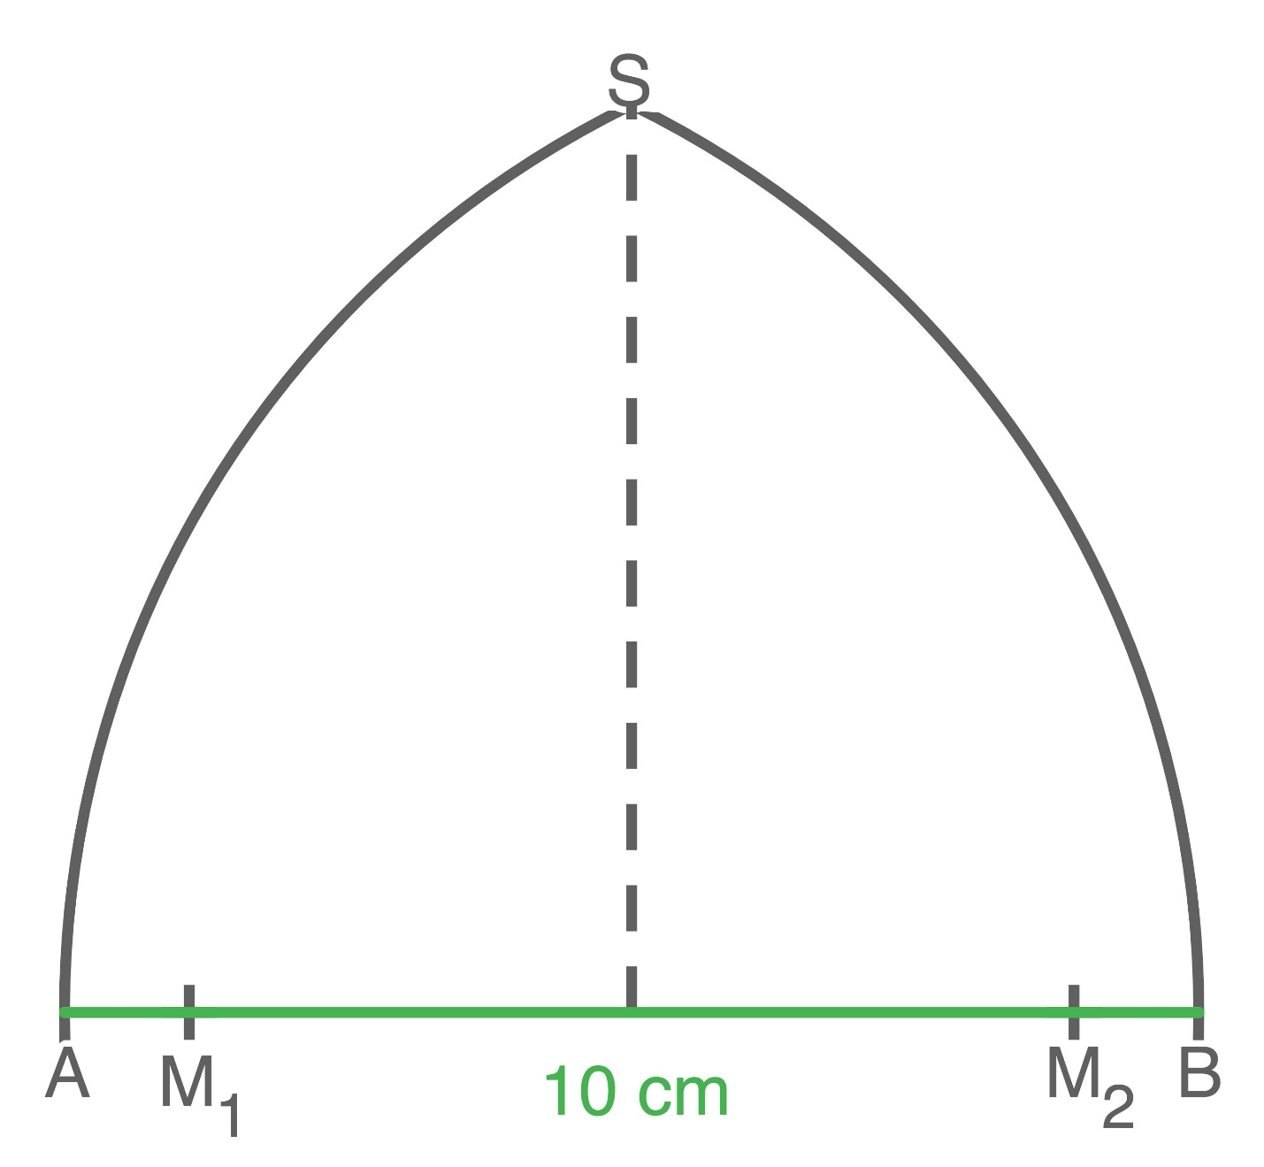
For a vertical parabola, the axis of symmetry has the form:
$$\boxed{x=h}$$

6. Asymmetric Parabolic Open Curve
# Source: AI Source: Provided by: [Data Path: Persons Table -> ID Column: 1, Name_En Column: Motasem Essam] -> From: [ChatGPT] on [7/25/2026]
A selected portion of a parabola can appear asymmetric when the endpoints are chosen at unequal distances from the vertex or axis of symmetry.
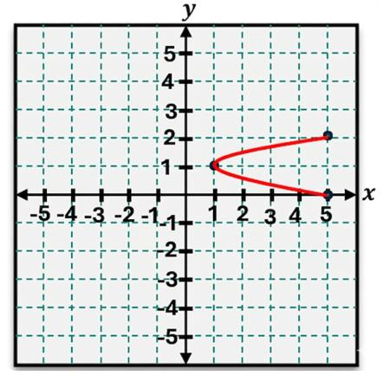
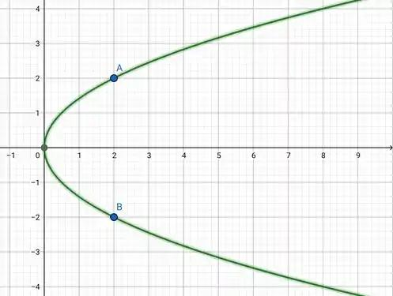
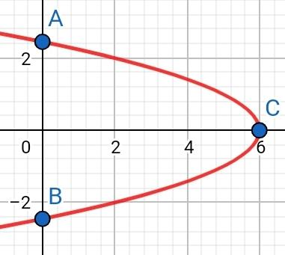
The underlying parabola remains symmetric, but the selected open portion does not necessarily appear symmetric.

7. Short Parabolic Arc
# Source: AI Source: Provided by: [Data Path: Persons Table -> ID Column: 1, Name_En Column: Motasem Essam] -> From: [ChatGPT] on [7/25/2026]
A short finite portion of a parabola between two selected points.
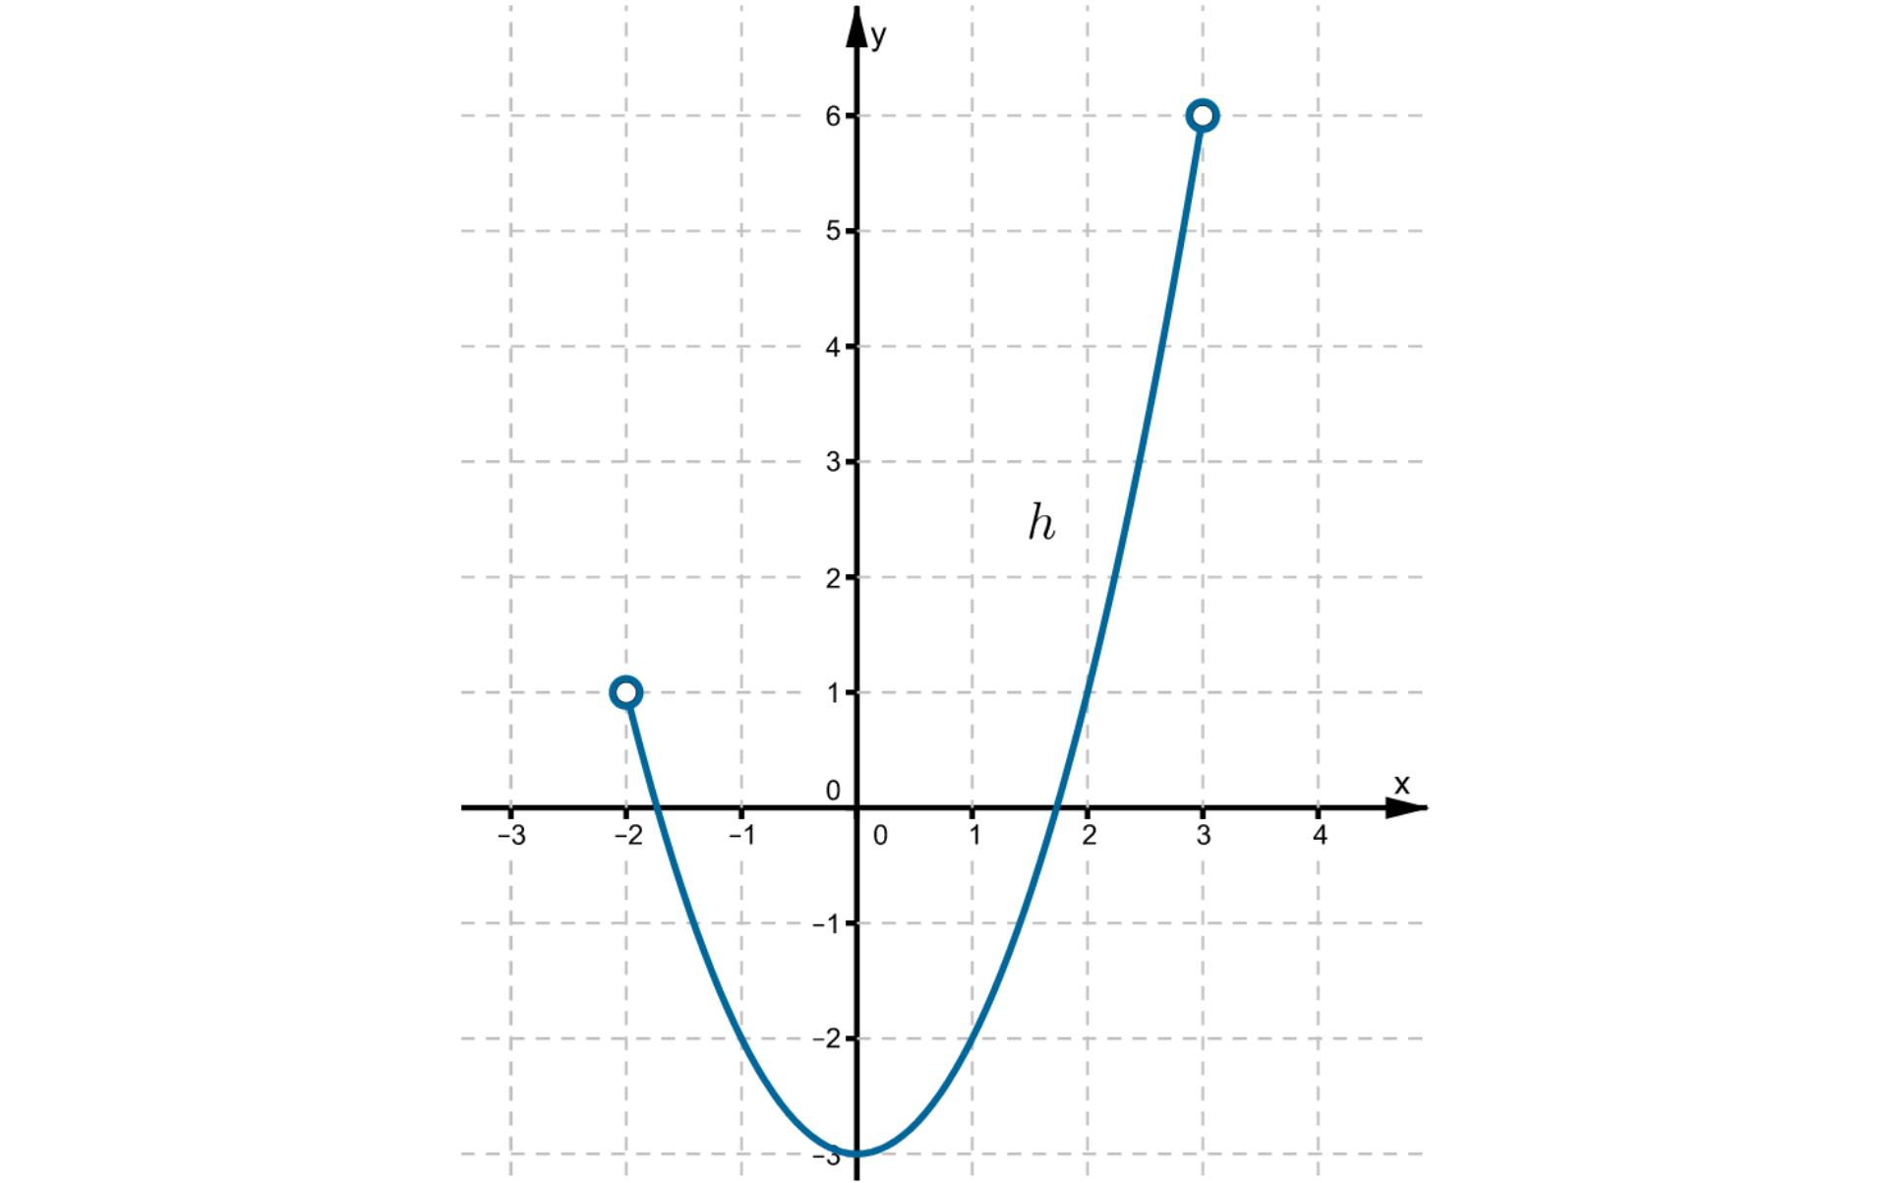
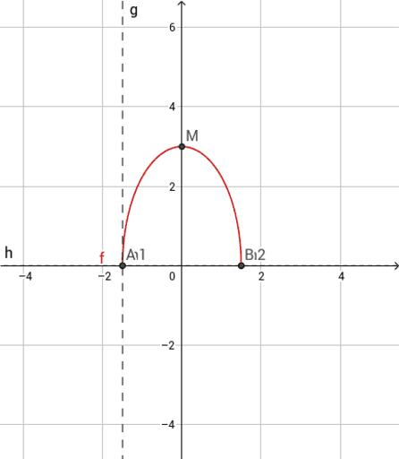
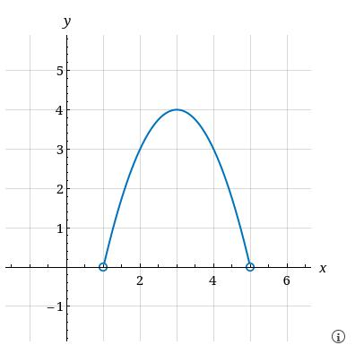
This is useful when a parabola forms only part of a larger shape.

8. Long Parabolic Arc
# Source: AI Source: Provided by: [Data Path: Persons Table -> ID Column: 1, Name_En Column: Motasem Essam] -> From: [ChatGPT] on [7/25/2026]
A longer finite portion of a parabola between two endpoints.
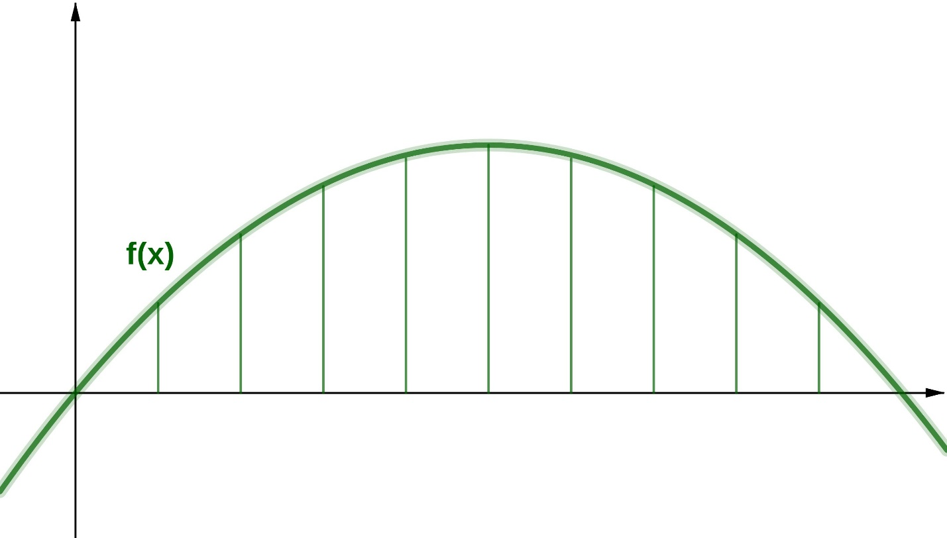
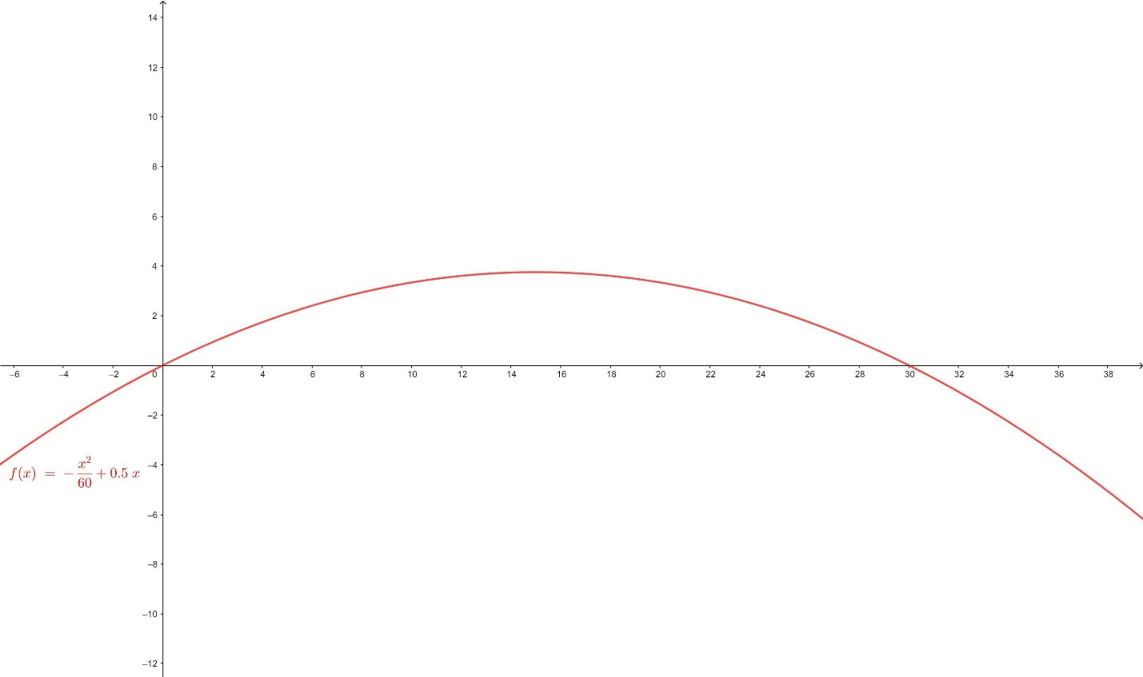

9. Vertex-Centered Parabolic Arc
# Source: AI Source: Provided by: [Data Path: Persons Table -> ID Column: 1, Name_En Column: Motasem Essam] -> From: [ChatGPT] on [7/25/2026]
The selected portion contains the vertex of the parabola.
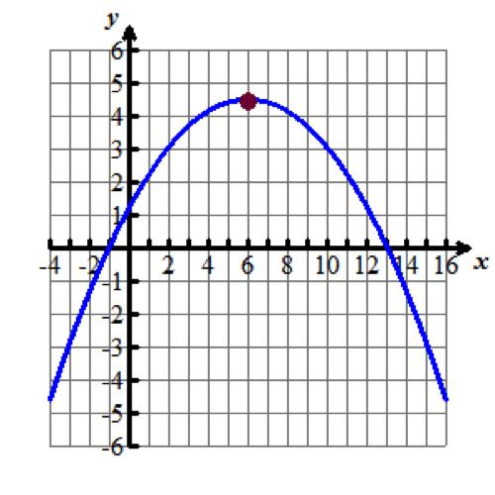
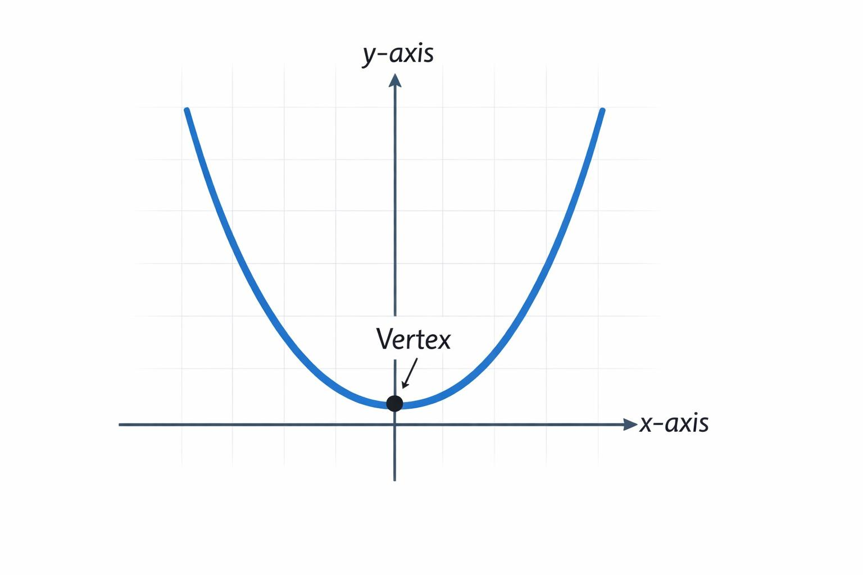
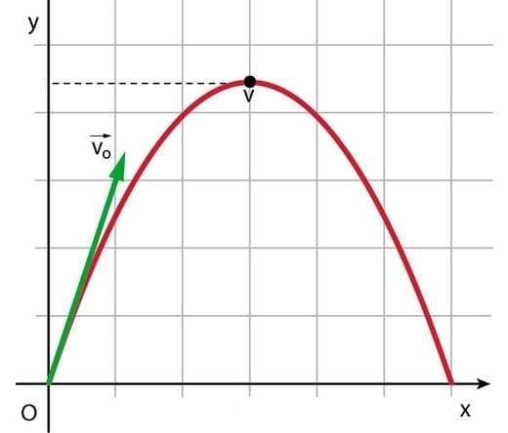
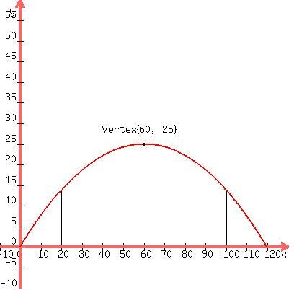
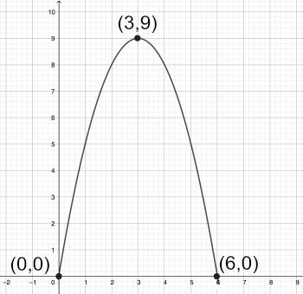
This type clearly shows the characteristic turning point of the parabola.

10. One-Sided Parabolic Arc
# Source: AI Source: Provided by: [Data Path: Persons Table -> ID Column: 1, Name_En Column: Motasem Essam] -> From: [ChatGPT] on [7/25/2026]
The selected portion extends from the vertex or another point primarily in one direction.
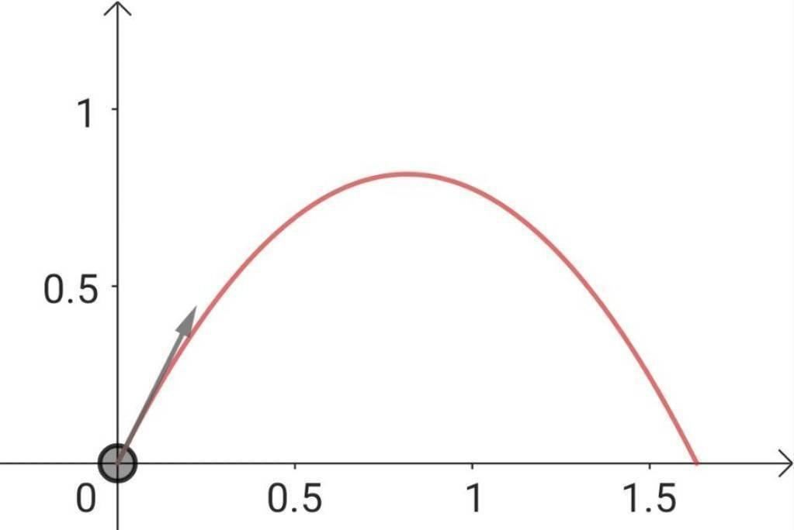
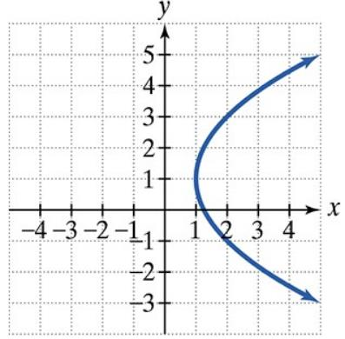
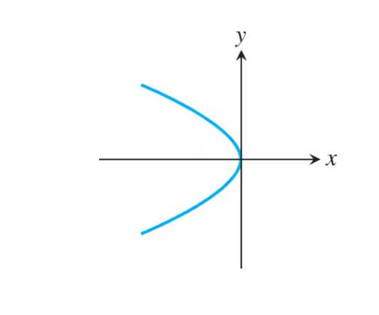
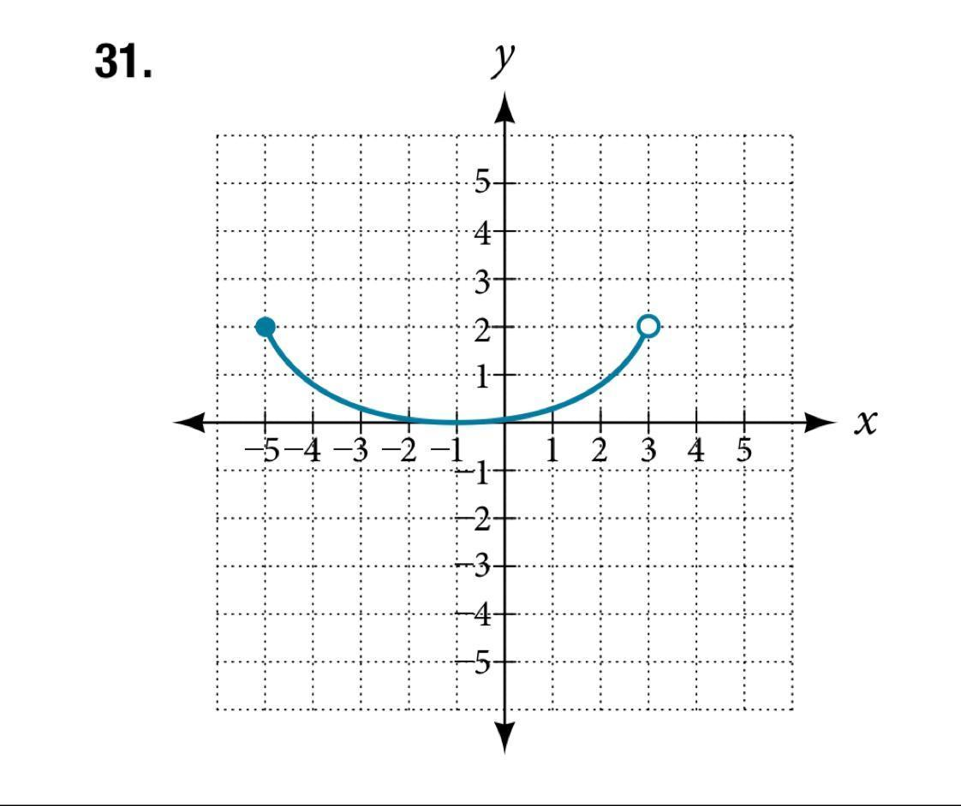
It may represent the left or right side of a vertical parabola.

11. Multi-Segment Parabolic-Looking Curve
# Source: AI Source: Provided by: [Data Path: Persons Table -> ID Column: 1, Name_En Column: Motasem Essam] -> From: [ChatGPT] on [7/25/2026]
Several connected parabolic portions can create a larger open curved path.
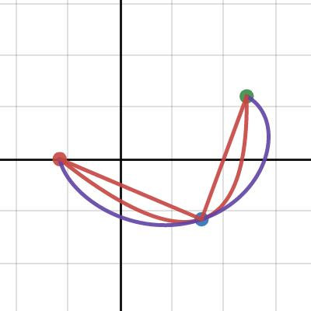
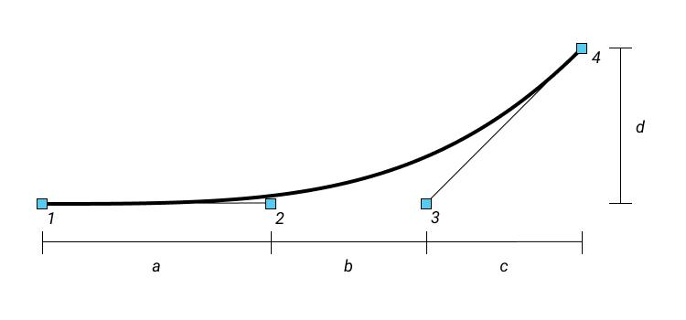
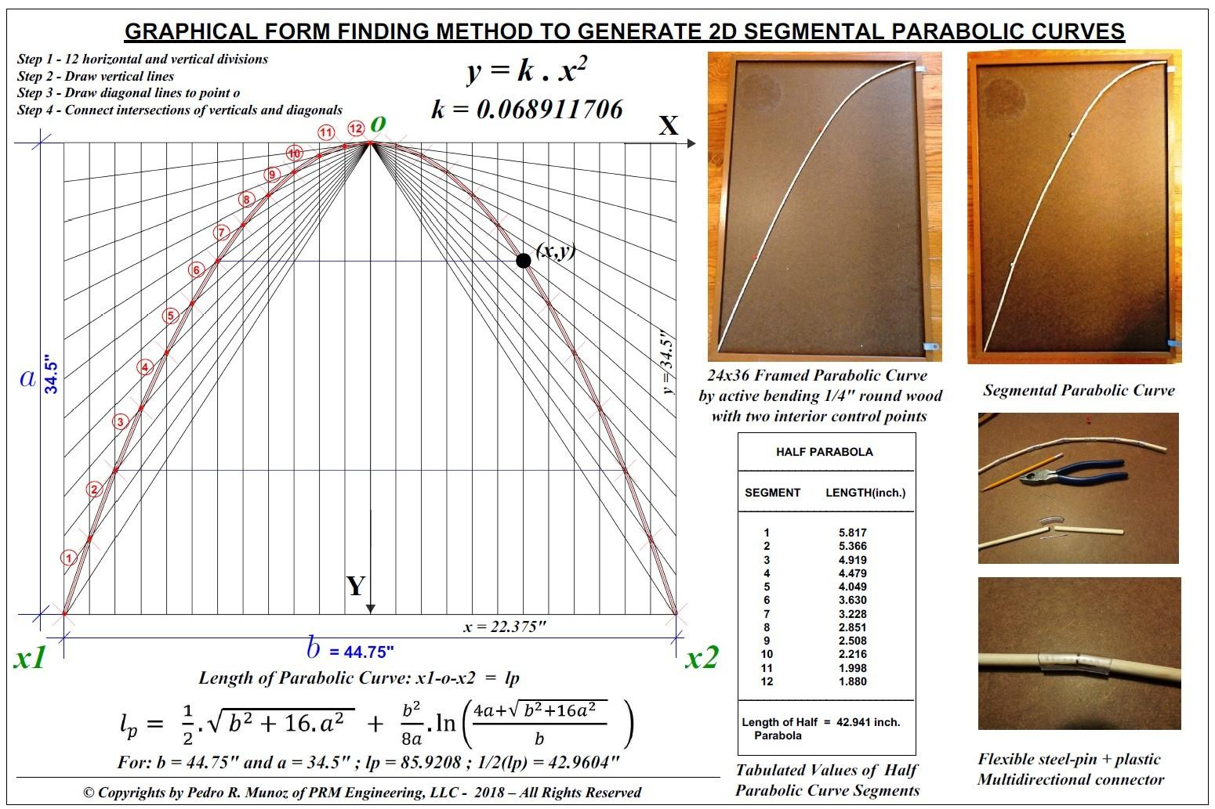
This is useful in composite or freeform designs.

12. Irregular Parabolic Open Curve
# Source: AI Source: Provided by: [Data Path: Persons Table -> ID Column: 1, Name_En Column: Motasem Essam] -> From: [ChatGPT] on [7/25/2026]
A finite portion of a parabola is combined with other curves or positioned irregularly within a larger open shape.
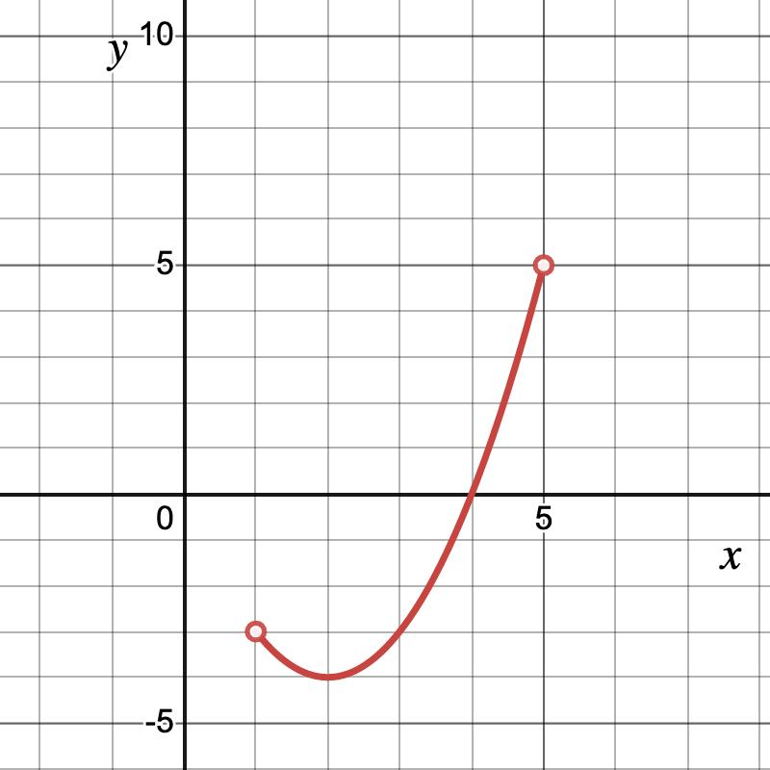
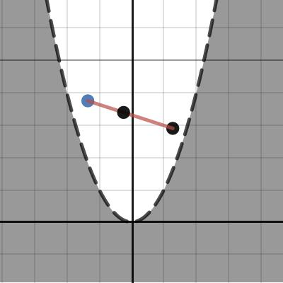
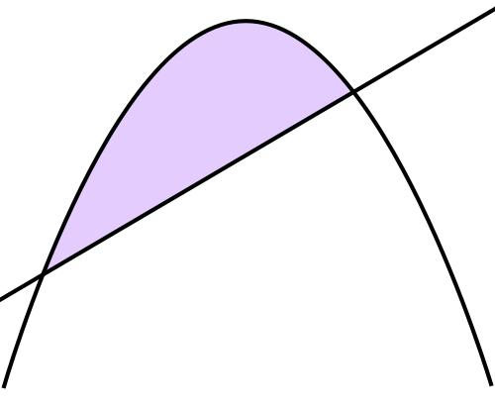

Parabolic Curve vs. Circular Arc
# Source: AI Source: Provided by: [Data Path: Persons Table -> ID Column: 1, Name_En Column: Motasem Essam] -> From: [ChatGPT] on [7/25/2026]
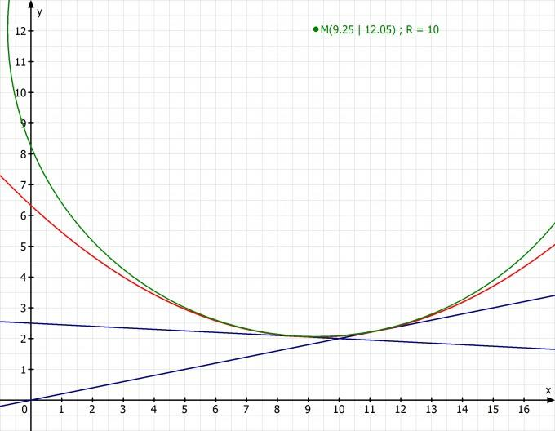
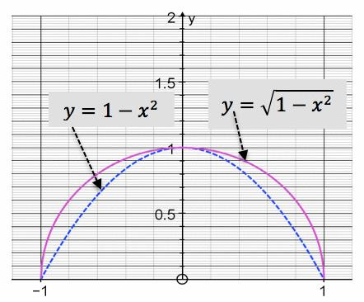
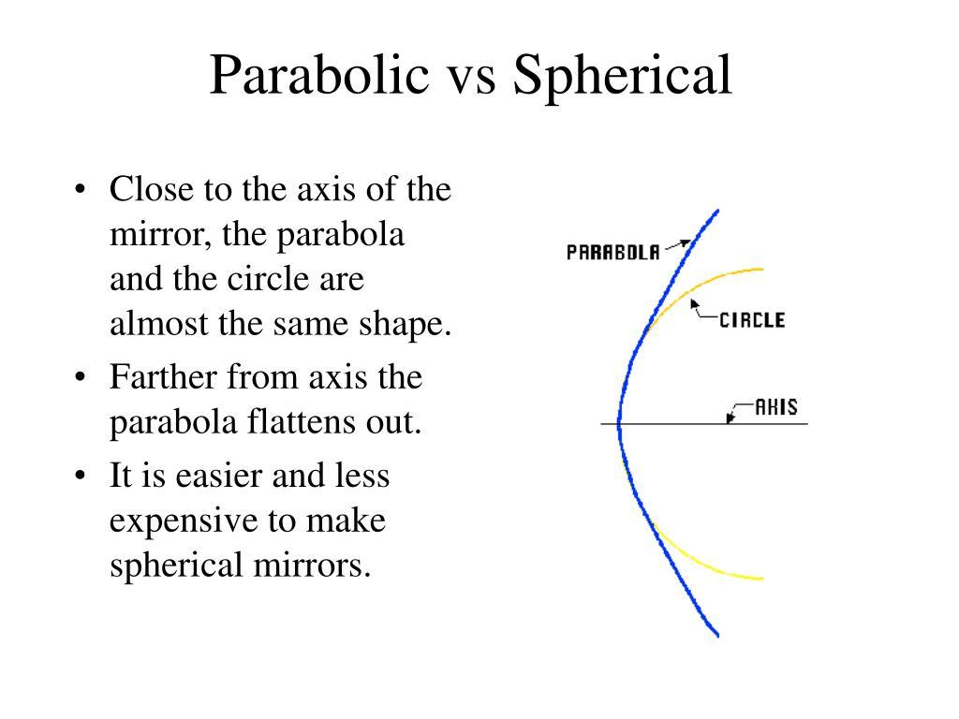
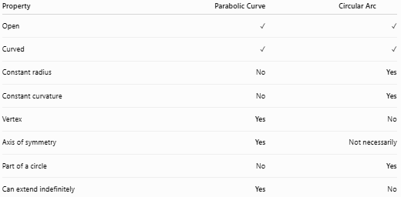
Property | Parabolic Curve | Circular Arc
Open | ✓ | ✓
Curved | ✓ | ✓
Constant radius | No | Yes
Constant curvature | No | Yes
Vertex | Yes | No
Axis of symmetry | Yes | Not necessarily
Part of a circle | No | Yes
Can extend indefinitely | Yes | No

Parabolic Curve vs. Complete Closed Curve
# Source: AI Source: Provided by: [Data Path: Persons Table -> ID Column: 1, Name_En Column: Motasem Essam] -> From: [ChatGPT] on [7/25/2026]
A parabola is fundamentally different from a circle or ellipse because it does not have a closed version.
$$\boxed{\text{Parabola}→\text{Open}}$$
whereas:
$$\boxed{\text{Circle}→\text{Closed}}$$
and:
$$\boxed{\text{Ellipse}→\text{Closed}}$$

Mathematical Representation
# Source: AI Source: Provided by: [Data Path: Persons Table -> ID Column: 1, Name_En Column: Motasem Essam] -> From: [ChatGPT] on [7/25/2026]
A standard vertical parabola can be written as:
$$\boxed{y=a{\left(x-h\right)}^{2}+k}$$
where:
- $a$ controls the opening and width.
- $\left(h,k\right)$ is the vertex.
- $x=h$ is the axis of symmetry.
A horizontal parabola can be written as:
$$\boxed{x=a{\left(y-k\right)}^{2}+h}$$

Key Points
# Source: AI Source: Provided by: [Data Path: Persons Table -> ID Column: 1, Name_En Column: Motasem Essam] -> From: [ChatGPT] on [7/25/2026]
A Parabolic Open Curve is:
$$\boxed{\text{Open}+\text{Parabolic Form}+\text{Continuous Curvature}}$$
It:
- Is based on a parabola.
- Has a characteristic vertex.
- Has an axis of symmetry.
- Can open upward, downward, left, or right.
- Can be a short or long finite portion of a parabola.
- Can extend indefinitely.
- Does not enclose an area by itself.
- Can appear symmetric or asymmetric depending on the selected portion.
Most important distinction
$$\boxed{\text{Parabolic Open Curve}≠\text{Circular Arc}}$$
A circular arc has constant curvature, while a parabola's curvature changes along the curve.

Conclusion
# Source: AI Source: Provided by: [Data Path: Persons Table -> ID Column: 1, Name_En Column: Motasem Essam] -> From: [ChatGPT] on [7/25/2026]
Parabolic Open Curves are open curved shapes based on the geometry of a parabola. They can be classified by their opening direction, selected extent, symmetry, relationship to the vertex, and role within a larger shape. Unlike circular and elliptical curves, a complete parabola is inherently open and can extend indefinitely.

